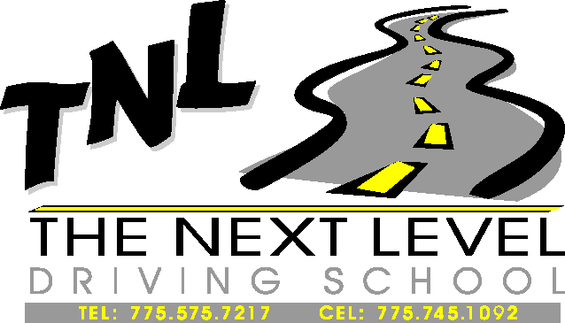

TECHNICAL INSPECTION FORM

THE NEXT LEVEL DRIVING SCHOOL

DRIVER NAME__________________________________________ CAR # _______

CAR MAKE ___________________ MODEL _______________ YEAR _______

INSTRUCTIONS:
Prior to bringing your car to the track or to registration, inspect each item on the car as noted on this sheet. Consult a mechanic if you have any questions. Submit the completed form to registration. Making sure that your car is “track ready” is your responsibility.

WHEELS & TIRES | ENGINE | BRAKES
___ Condition of tires | ___ Fluid leaks (oil, fuel, water) | ___ Pedal pressure
___ All lug nuts present & tight | ___ Radiator overflow | ___ Fluid level
___ No hubcaps or beauty rings | ___ Battery secured (no bungees) | ___ Lines (condition)
 | ___ Battery terminals covered | ___ Brake lights
SAFETY EQUIPMENT | ___ Radiator hoses condition
___ Roll bars in open cars | ___ No coolant present | MISCELLANEOUS
___ Seat belts or Safety harness | ___ Fluid lines (condition) | ___ Gas cap secured
___ Helmet (Snell SA95 or newer) |  | ___ No wires exposed
___ Covered battery inside cockpit | STEERING & SUSPENSION | ___ Seats bolted tight
 | ___ Wheel bearings, F+R | ___ Camera secure
 | ___ Steering play

At the Track:
No loose objects in the car or the trunk. Remove spare tire, jack, floor mats, dash mats, paper, etc.
Tech sticker and track event sticker on left top of windshield.
Cover all exposed lights with tape, except brake lights.
A nomex suit is recommended, but not required.
I have inspected the above vehicle and take full responsibility for its condition on the track. I have read Reno-Fernley Raceway’s Road Course Rules. The car and the driver meet or exceed all requirements in RFR’s rules, even those not listed here.

SIGNATURE OF OWNER/DRIVER _____________________________ DATE _______________

INSPECTED BY (RFR OFFICIAL) ______________________________ DATE _______________

